PRESS RELEASE
FOR IMMEDIATE RELEASE

Contact: Cris Worley, cris@crisworley.com
Cris Worley Fine Arts
1845 Levee St. #110
Dallas, TX 75207
214-745-1415

Exhibition Title: Kelli Vance: We Don’t Sleep
Exhibition Dates: May 21 – June 25, 2022
Opening reception (artist will be in attendance): Saturday, May 21st, 5 – 8 pm

Cris Worley Fine Arts in Dallas is pleased to announce the upcoming exhibition, Kelli Vance: We Don’t Sleep, which opens May 21st and runs through June 25th with an artist’s reception on Saturday, May 21st from June 25th. This is the Houston-based artist’s fourth solo exhibition with the gallery.

Vance’s luxurious and masterly paintings have often presented women in states of anomie or conflict—personal, social, physical. This is the feminine in a quietly hostile environment of her own making, or trapped in a set of expectations that she either works with, to maintain equilibrium, or against, with mixed results—sometimes defeated, sometimes defiant. Vance’s women are in a kind of unseen, unstoppable trouble, or they are recalling it, or are bracing for it. They are often in their final minutes of innocence before the sinister shadow overtakes the narrative.

Fittingly, in our current moment, Vance’s newest paintings take this Lynchian dread a step further. (Maybe three steps further. Their cinematic corollaries are perhaps Blue Velvet and Mulholland Drive.) We can’t see the women’s faces anymore—apropos following two years of facial deprivation—and yet their circumstances are in sharper focus. These narratives, loaded with decadent and sumptuous detail, are infused with a strange and layered power: on the one hand they carry the beauty of almost photographic refinement and high glamour, which is only heightened by the painter’s subjective eye. On the other hand, these images vibrate with ineffable anxiety. Things are too quiet, too strange.

As viewers, we shift back and forth between states of admiration of the subjects’ elegance and seductiveness—these women are in control, at the ready, waiting for the arrival of something sublime, or pedestrian, or terrifying—and apprehension concerning their imminent fates. Is the danger roiling up from within, or descending from without? This is gorgeous and unsettling work.

The title of the exhibition sums it up. We’re dressed for the party, but there is no return to normal. We don’t sleep. Not anymore.

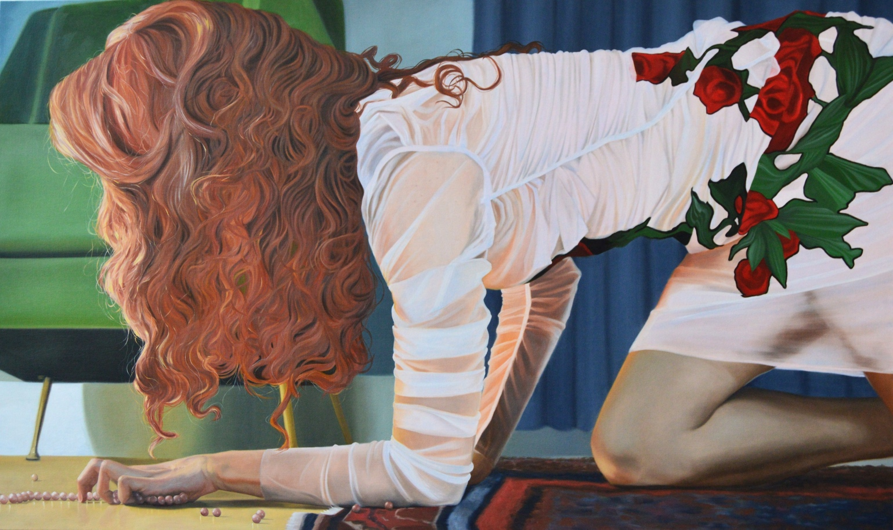

Kelli Vance
The Gut Wrenching Beauty Of It All, 2022
Oil on canvas
42 x 72 inches

